**DDL**

1. Create following tables with corresponding attributes:

CREATE TABLE airline_info (

airline_id INT NOT NULL PRIMARY KEY,

airline_code VARCHAR(30) NOT NULL,

airline_name VARCHAR(50) NOT NULL,

airline_country VARCHAR(50) NOT NULL,

created_at TIMESTAMP NOT NULL,

updated_at TIMESTAMP NOT NULL,

info VARCHAR(50) NOT NULL

);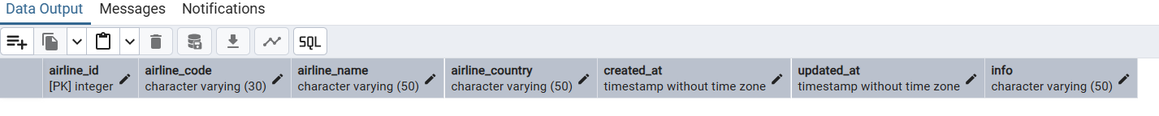

CREATE TABLE airport (

airport_id INT NOT NULL PRIMARY KEY,

airport_name VARCHAR(50) NOT NULL,

country VARCHAR(50) NOT NULL,

state VARCHAR(50) NOT NULL,

city VARCHAR(50) NOT NULL,

created_at TIMESTAMP NOT NULL,

updated_at TIMESTAMP NOT NULL

);

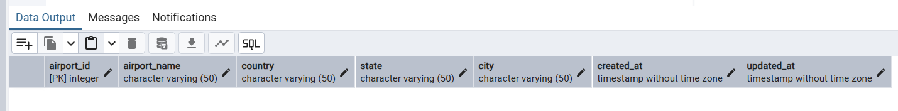

CREATE TABLE passengers (

passenger_id INT NOT NULL PRIMARY KEY,

first_name VARCHAR(50) NOT NULL,

last_name VARCHAR(50) NOT NULL,

date_of_birth DATE NOT NULL,

gender VARCHAR(50) NOT NULL,

country_of_citizenship VARCHAR(50) NOT NULL,

country_of_residence VARCHAR(50) NOT NULL,

passport_number VARCHAR(20) NOT NULL,

created_at TIMESTAMP NOT NULL,

updated_at TIMESTAMP NOT NULL

);

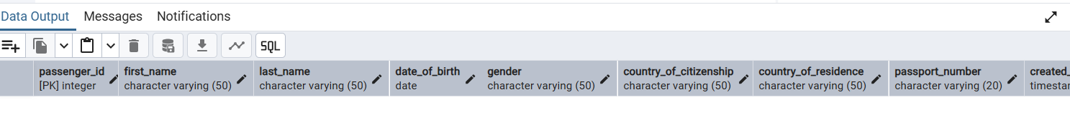

CREATE TABLE security_check (

security_check_id INT NOT NULL PRIMARY KEY,

check_result VARCHAR(20) NOT NULL,

created_at TIMESTAMP NOT NULL,

updated_at TIMESTAMP NOT NULL,

passenger_id INT NOT NULL,

CONSTRAINT fk_security_passenger FOREIGN KEY (passenger_id) REFERENCES passengers (passenger_id)

);

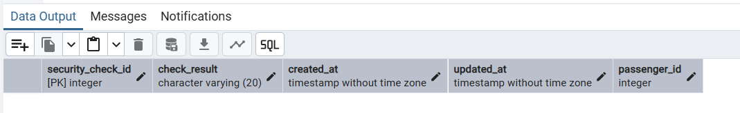

CREATE TABLE booking (

booking_id INT NOT NULL PRIMARY KEY,

flight_id INT NOT NULL,

passenger_id INT NOT NULL,

booking_platform VARCHAR(50) NOT NULL,

created_at TIMESTAMP NOT NULL,

updated_at TIMESTAMP NOT NULL,

status VARCHAR(50) NOT NULL,

price DECIMAL(7,2) NOT NULL

);

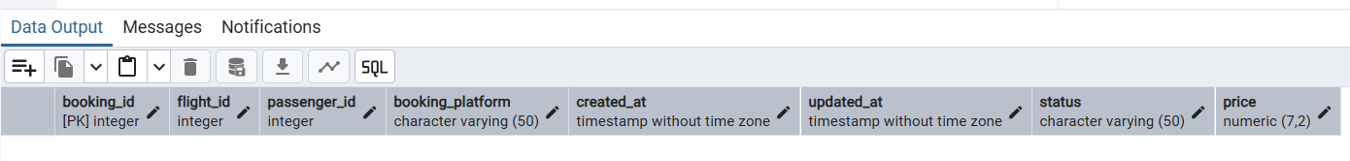

CREATE TABLE baggage_check (

baggage_check_id INT NOT NULL PRIMARY KEY,

check_result VARCHAR(50) NOT NULL,

created_at TIMESTAMP NOT NULL,

updated_at TIMESTAMP NOT NULL,

booking_id INT NOT NULL,

passenger_id INT NOT NULL,

CONSTRAINT fk_baggagecheck_booking FOREIGN KEY (booking_id) REFERENCES booking (booking_id),

CONSTRAINT fk_baggagecheck_passenger FOREIGN KEY (passenger_id) REFERENCES passengers (passenger_id)

);

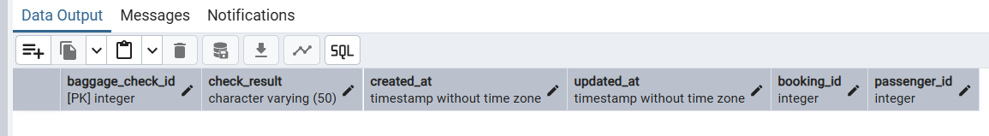

CREATE TABLE baggage (

baggage_id INT NOT NULL PRIMARY KEY,

weight_in_kg DECIMAL(4,2) NOT NULL,

created_at TIMESTAMP NOT NULL,

updated_at TIMESTAMP NOT NULL,

booking_id INT NOT NULL,

CONSTRAINT fk_baggage_booking FOREIGN KEY (booking_id) REFERENCES booking (booking_id)

);

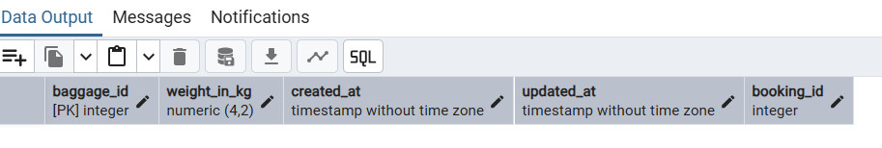

CREATE TABLE boarding_pass (

boarding_pass_id INT NOT NULL PRIMARY KEY,

booking_id INT NOT NULL,

seat VARCHAR(50) NOT NULL,

boarding_time TIMESTAMP NOT NULL,

created_at TIMESTAMP NOT NULL,

updated_at TIMESTAMP NOT NULL,

CONSTRAINT fk_boardingpass_booking FOREIGN KEY (booking_id) REFERENCES booking (booking_id)

);

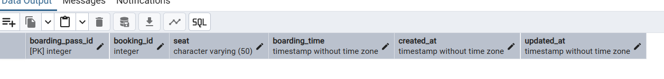

CREATE TABLE flights (

flight_id INT NOT NULL PRIMARY KEY,

sch_departure_time TIMESTAMP NOT NULL,

sch_arrival_time TIMESTAMP NOT NULL,

departing_airport_id INT NOT NULL,

arriving_airport_id INT NOT NULL,

departing_gate VARCHAR(50) NOT NULL, -- изменим на TEXT ниже, как в требовании

arriving_gate VARCHAR(50) NOT NULL,

airline_id INT NOT NULL,

act_departure_time TIMESTAMP NOT NULL,

act_arrival_time TIMESTAMP NOT NULL,

created_at TIMESTAMP NOT NULL,

updated_at TIMESTAMP NOT NULL,

CONSTRAINT fk_flights_departure_airport FOREIGN KEY (departing_airport_id) REFERENCES airport (airport_id),

CONSTRAINT fk_flights_arrival_airport FOREIGN KEY (arriving_airport_id) REFERENCES airport (airport_id),

CONSTRAINT fk_flights_airline FOREIGN KEY (airline_id) REFERENCES airline_info (airline_id)

);

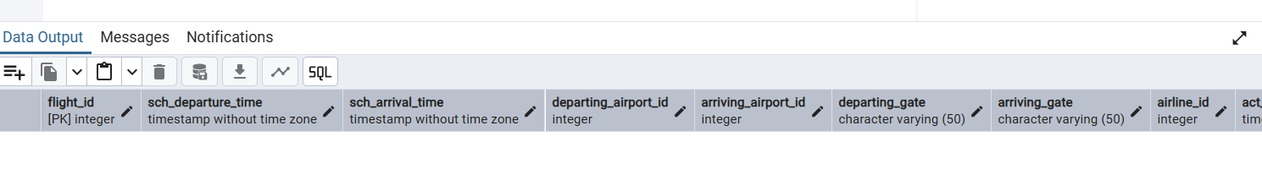

CREATE TABLE booking_flight (

booking_flight_id INT NOT NULL PRIMARY KEY,

booking_id INT NOT NULL,

flight_id INT NOT NULL,

created_at TIMESTAMP NOT NULL,

updated_at TIMESTAMP NOT NULL,

CONSTRAINT fk_bookingflight_booking FOREIGN KEY (booking_id) REFERENCES booking (booking_id),

CONSTRAINT fk_bookingflight_flight FOREIGN KEY (flight_id) REFERENCES flights (flight_id)

);

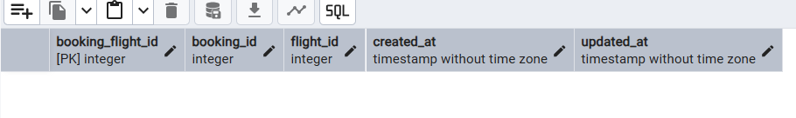

ALTER TABLE airline_info RENAME TO airline;

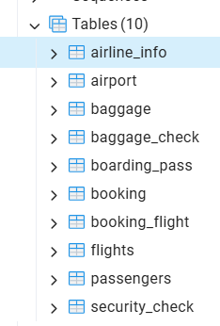 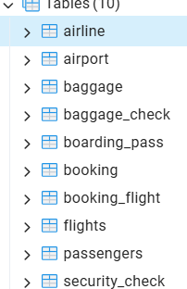

ALTER TABLE booking RENAME COLUMN price TO ticket_price;



ALTER TABLE flights ALTER COLUMN departing_gate TYPE TEXT;

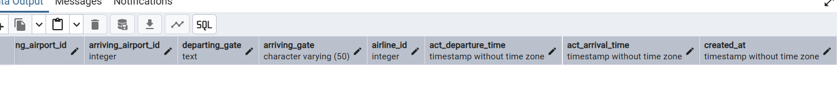

ALTER TABLE airline DROP COLUMN info;



9 task created with tables

**DML**

1. Generate and insert 200 random rows in your airport database.

BEGIN;

-- 1) airport (200 rows)

INSERT INTO airport (airport_id, airport_name, country, state, city, created_at, updated_at)

SELECT g,

'Airport_' || g,

'Country_' || ((g % 30) + 1),

'State_' || ((g % 50) + 1),

'City_' || ((g % 100) + 1),

now() - ( (g % 30) || ' days')::interval,

now() - ( ((g+1) % 10) || ' days')::interval

FROM generate_series(1,200) AS g;

-- 2) airline (200 rows) (у тебя таблица переименована из airline_info -> airline)

INSERT INTO airline (airline_id, airline_code, airline_name, airline_country, created_at, updated_at)

SELECT g,

'AL' || lpad((g % 999)::text,3,'0'),

'Airline_' || g,

'Country_' || ((g % 25) + 1),

now() - ( ((g*2) % 40) || ' days')::interval,

now() - ( ((g*3) % 5) || ' days')::interval

FROM generate_series(1,200) AS g;

-- 3) passengers (200 rows)

INSERT INTO passengers (

passenger_id, first_name, last_name, date_of_birth, gender,

country_of_citizenship, country_of_residence, passport_number,

created_at, updated_at

)

SELECT g,

'FirstName_' || (g % 100),

'LastName_' || g,

(current_date - ((18 + (g % 63)) || ' years')::interval)::date, -- возраст 18..80

CASE WHEN (g % 2)=0 THEN 'Female' ELSE 'Male' END,

'Country_' || ((g % 25) + 1),

'Country_' || (( (g+5) % 25) + 1),

upper(substr(md5(g::text || clock_timestamp()::text),1,10)),

now() - ( ((g*5) % 60) || ' days')::interval,

now() - ( ((g*2) % 7) || ' days')::interval

FROM generate_series(1,200) AS g;

-- 4) flights (200 rows)

-- departing_airport_id and arriving_airport_id chosen randomly 1..200 (may coincide sometimes)

INSERT INTO flights (

flight_id, sch_departure_time, sch_arrival_time,

departing_airport_id, arriving_airport_id,

departing_gate, arriving_gate,

airline_id, act_departure_time, act_arrival_time,

created_at, updated_at

)

SELECT g,

now() + ((g % 7) || ' days')::interval + ((g % 24) || ' hours')::interval,

now() + ((g % 7) || ' days')::interval + (((g % 24)+2) || ' hours')::interval,

((random()*199)::int + 1), -- random airport id 1..200

((random()*199)::int + 1), -- random airport id 1..200

'Gate_' || ((g % 50) + 1),

'Gate_' || (((g+3) % 50) + 1),

((random()*199)::int + 1), -- random airline 1..200

now() + (((g+1) % 7) || ' days')::interval + (((g+3) % 24) || ' hours')::interval,

now() + (((g+1) % 7) || ' days')::interval + (((g+5) % 24) || ' hours')::interval,

now() - ( ((g*3) % 10) || ' days')::interval,

now() - ( ((g*2) % 3) || ' days')::interval

FROM generate_series(1,200) AS g;

-- 5) booking (200 rows)

-- booking.flight_id set to a random flight (1..200) to keep plausible; passenger_id random 1..200

INSERT INTO booking (

booking_id, flight_id, passenger_id, booking_platform,

created_at, updated_at, status, ticket_price

)

SELECT g,

((random()*199)::int + 1), -- random flight id

((random()*199)::int + 1), -- random passenger id

CASE (g % 4)

WHEN 0 THEN 'Website'

WHEN 1 THEN 'MobileApp'

WHEN 2 THEN 'Agent'

ELSE 'Kiosk'

END,

now() - ((g % 40) || ' days')::interval,

now() - ((g % 10) || ' days')::interval,

CASE (g % 5)

WHEN 0 THEN 'CONFIRMED'

WHEN 1 THEN 'CANCELLED'

WHEN 2 THEN 'CHECKED_IN'

WHEN 3 THEN 'PENDING'

ELSE 'COMPLETED'

END,

( (100 + (random()*900))::numeric(7,2) ) -- price between 100 and 1000

FROM generate_series(1,200) AS g;

-- 6) booking_flight (200 rows)

-- booking_id 1..200, flight_id random 1..200

INSERT INTO booking_flight (

booking_flight_id, booking_id, flight_id, created_at, updated_at

)

SELECT g,

g, -- map booking_flight_id -> booking_id (ensures booking exists)

((random()*199)::int + 1),

now() - (((g*2) % 20) || ' days')::interval,

now() - (((g*3) % 7) || ' days')::interval

FROM generate_series(1,200) AS g;

-- 7) boarding_pass (200 rows)

-- booking_id random 1..200

INSERT INTO boarding_pass (

boarding_pass_id, booking_id, seat, boarding_time, created_at, updated_at

)

SELECT g,

((random()*199)::int + 1),

( (CHR(65 + (g % 6)) || (1 + (g % 30))::text) ), -- seats like A1..F30

now() + ((g % 3) || ' days')::interval + ((g % 12) || ' hours')::interval,

now() - (((g+2) % 12) || ' days')::interval,

now() - (((g+1) % 5) || ' days')::interval

FROM generate_series(1,200) AS g;

-- 8) baggage (200 rows)

INSERT INTO baggage (

baggage_id, weight_in_kg, created_at, updated_at, booking_id

)

SELECT g,

( (5 + random()*35)::numeric(4,2) ), -- weight 5.00 .. 40.00

now() - (((g*4) % 30) || ' days')::interval,

now() - (((g*2) % 6) || ' days')::interval,

((random()*199)::int + 1)

FROM generate_series(1,200) AS g;

-- 9) baggage_check (200 rows)

INSERT INTO baggage_check (

baggage_check_id, check_result, created_at, updated_at, booking_id, passenger_id

)

SELECT g,

CASE (g % 3)

WHEN 0 THEN 'OK'

WHEN 1 THEN 'OVERWEIGHT'

ELSE 'NEEDS_INSPECTION'

END,

now() - ((g % 15) || ' days')::interval,

now() - (((g+3) % 7) || ' hours')::interval,

((random()*199)::int + 1),

((random()*199)::int + 1)

FROM generate_series(1,200) AS g;

-- 10) security_check (200 rows)

INSERT INTO security_check (

security_check_id, check_result, created_at, updated_at, passenger_id

)

SELECT g,

CASE (g % 4)

WHEN 0 THEN 'CLEARED'

WHEN 1 THEN 'FLAGGED'

WHEN 2 THEN 'ADDITIONAL_SCREEN'

ELSE 'DENIED'

END,

now() - (((g*7) % 20) || ' days')::interval,

now() - (((g*2) % 3) || ' hours')::interval,

((random()*199)::int + 1)

FROM generate_series(1,200) AS g;

COMMIT;

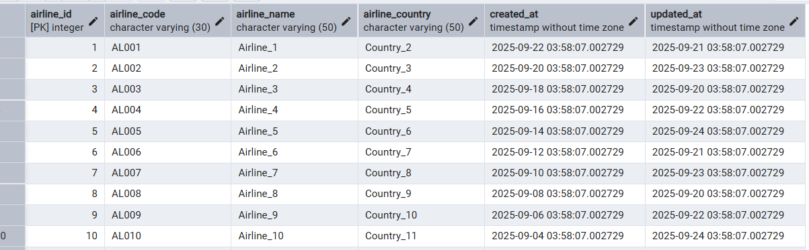

2 task

INSERT INTO airline (airline_id, airline_code, airline_name, airline_country, created_at, updated_at)

VALUES (201, 'KZ001', 'KazAir', 'Kazakhstan', NOW(), NOW());



3 task

update airline set airline_country='Turkey' where airline_name='KazAir';

SELECT * FROM airline;



4 task

INSERT INTO airline (airline_id, airline_code, airline_name, airline_country, created_at, updated_at)

VALUES (202, 'CH012', 'CHINAIR', 'China', NOW(), NOW()),

(203, 'FR018', 'PARISair','France',NOW(),NOW()),

(204, 'USA111','LA','NY',NOW(),NOW());

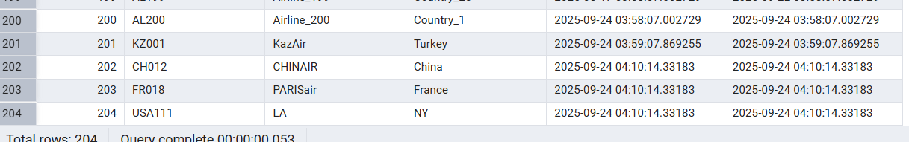

INSERT INTO airline (airline_id, airline_code, airline_name, airline_country, created_at, updated_at)

VALUES

(205, 'FR001', 'AirEasy', 'France', NOW(), NOW()),

(206, 'BR001', 'FlyHigh', 'Brazil', NOW(), NOW()),

(207, 'PL001', 'FlyFly', 'Poland', NOW(), NOW());

select * from airline;

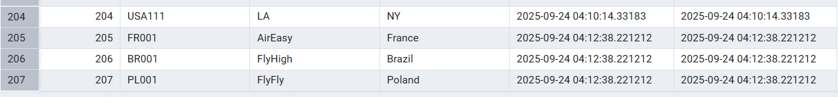

5 task

delete from flights where sch_arrival_time between '2024-01-01' and '2024-12-31' ;

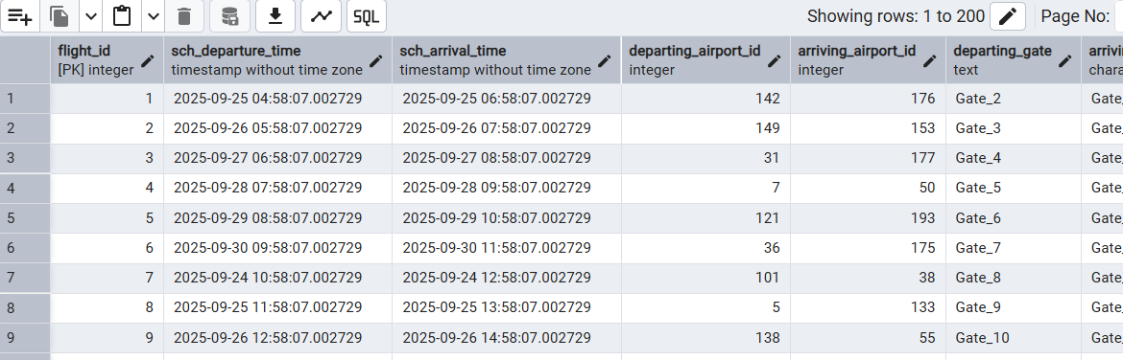

6 task

update booking set ticket_price = ticket_price * 1.15;

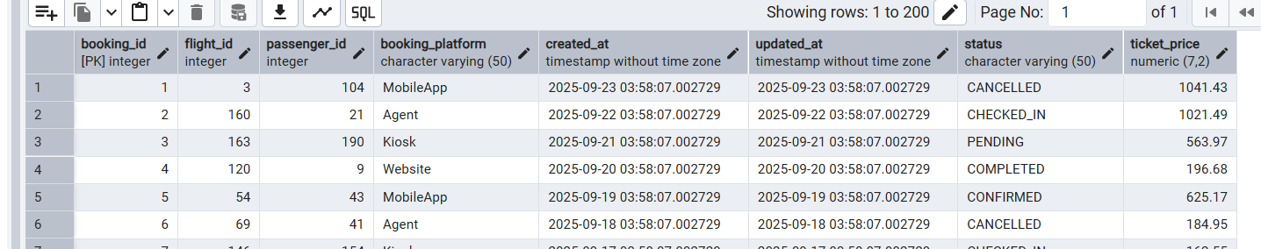

7 task

DELETE FROM baggage WHERE booking_id IN (SELECT booking_id FROM booking WHERE ticket_price < 10000);

DELETE FROM boarding_pass WHERE booking_id IN (SELECT booking_id FROM booking WHERE ticket_price < 10000);

DELETE FROM baggage_check WHERE booking_id IN (SELECT booking_id FROM booking WHERE ticket_price < 10000);

DELETE FROM booking_flight WHERE booking_id IN (SELECT booking_id FROM booking WHERE ticket_price < 10000);

DELETE FROM booking WHERE ticket_price < 10000;

select * from booking ;

